Background

📘 Definition
# Source: AI Source: Provided by: [Data Path: Persons Table -> ID Column: 1, Name_En Column: Motasem Essam] -> From: [ChatGPT] on [5/2/2026]
A background is the backmost part of an image, scene, or design that appears behind the main objects or subjects. It helps set the environment, mood, and context of what you are seeing.

🖼️ How background works
# Source: AI Source: Provided by: [Data Path: Persons Table -> ID Column: 1, Name_En Column: Motasem Essam] -> From: [ChatGPT] on [5/2/2026]


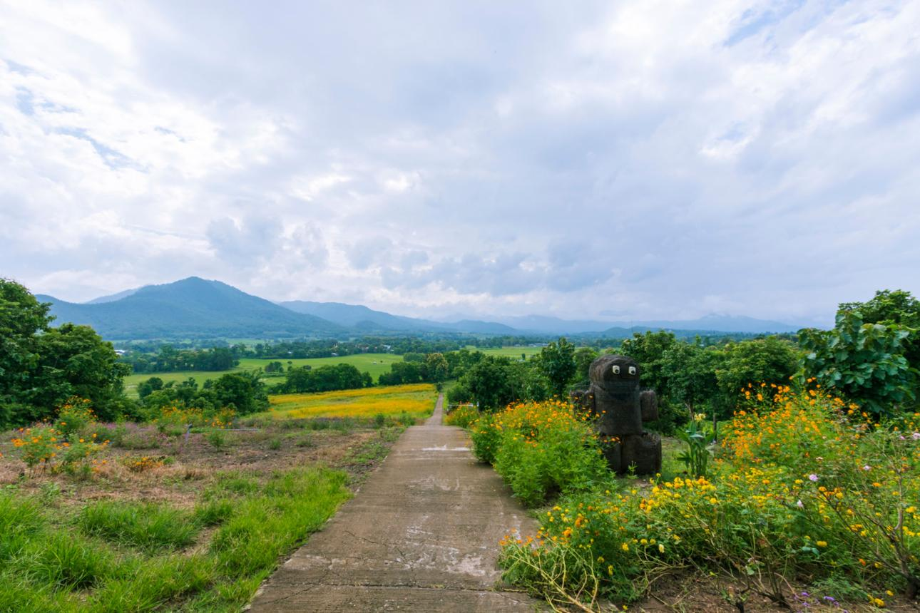
- The main object is in the front (foreground)
- The background is behind it
- It provides context and atmosphere
- It does not usually distract from the main subject

🧠 Simple example
# Source: AI Source: Provided by: [Data Path: Persons Table -> ID Column: 1, Name_En Column: Motasem Essam] -> From: [ChatGPT] on [5/2/2026]
Think of:
- 📸 A person taking a photo → the person is foreground, the sky or wall is background
- 🎮 A game scene → characters in front, mountains or sky behind
- 🎨 A poster → text/logo in front, design behind

🎮 Background in computer graphics
# Source: AI Source: Provided by: [Data Path: Persons Table -> ID Column: 1, Name_En Column: Motasem Essam] -> From: [ChatGPT] on [5/2/2026]
Backgrounds are used to:
- 🌍 Create environments (sky, landscape, rooms)
- 🎬 Set the mood of a scene (sunset, night, fog)
- 🎮 Build game worlds and levels
- 🎨 Improve visual design and composition

⚙️ Key features
# Source: AI Source: Provided by: [Data Path: Persons Table -> ID Column: 1, Name_En Column: Motasem Essam] -> From: [ChatGPT] on [5/2/2026]
- 🧭 Located at the back of the scene
- 🎨 Provides context and atmosphere
- 👁️ Supports the main subject without overpowering it
- 🧩 Can be simple (solid color) or complex (detailed environment)

🚀 In short:
# Source: AI Source: Provided by: [Data Path: Persons Table -> ID Column: 1, Name_En Column: Motasem Essam] -> From: [ChatGPT] on [5/2/2026]
Background = the part of an image or scene that appears behind the main objects and sets the environment and mood.

